Assignment 1(Intro to Web Dev)
- Explain the difference between frontend, backend, and full-stack development with suitable real-world examples.
Frontend: - It means that the whole thing that user see and interact with directly with a web page. It also says it as User interface (UI)
Frontend directly runs on browser
Frontend have key components: - Html, CSS and JavaScript
Let’s take an example: -
- The search bar, add to cart button on the amazon website all the part of frontend.
- Whenever we visit any website there are some images when we take a cursor on it then image become hover this is it helps of frontend (Html, CSS and JavaScript)
Backend: - Backend Development focused on the behind the scene logic and gives power to the frontend
Backend runs on server
Backend key components: - Nodejs, Java, Python
Let’s take an example: -
- Like Frontend have add to cart button on the amazon when we click add to cart button it checks
    - Its check first login status
    - Render the product from the database
    - Update the database with the new product
So directly we can say backend helps in business login.

Full-stack development
Full-stack development focus on frontend and backend both building the entire application end to end point.
Full-stack development runs both server and browser
Full-stack development key components are: -
- React + Node.js
- Angular + Node.js
- React +Spring
- Angular +Spring
Let’s take an example: -
- Entire Web App like Netflix clone
2. Create a simple diagram showing how the client-server model works in web architecture.
Server

Internet

Clients
Desktops
Laptops
Mobile

3. Describe how a browser requests and displays a web page from a web server.
When we type any website URL in the web browser, then browser finds the Ip address using the DNS and sends an HTTP request to it. Then web server processes the request and sends back an HTML response with other resources (CSS, JS, images, data of user). Finally, the browser renders these files to display the complete web page on your screen.
URL->URL SPLIT -> DOMAIN-> IP Address-> Connection of Web Server -> Https Requests -> Server process the request -> Http gets its response -> Browser render

4. Identify and list the tools required to set up a web development environment. Explain the purpose of each.
Tools Required: -
- Coder Editor: - use to write and read the code with syntax highlighting.
- Web Browser: - it allows to developer to test run, test and debug the web page.
- Version Controller: - It allows to track the changes in code, enables collaboration and manage the project.
- Runtime Environment: - Runs backend code and server web pages
- Package Manager: - Installs and manages libraries or dependencies used in projects.
- Database: - Stores and retrieves data used by web applications.
- Frameworks & Libraries: - Simplify development by providing prebuilt tools.
- Testing tools: - Used to test code quality, performance, and functionality.
- Design and protype tools: - Helps the developer to design UI before experiences the code
5. Explain what a web server is and give examples of commonly used servers.
A web server acts as middleware between user browser and website data.
It receives requests and sends back web content to be displayed.
Commonly used servers are: -
- Node js
- Nginx
- Tomcat
- LiteSpeed
6. Define the roles of a frontend developer, backend developer, and database administrator in a project.
Frontend Developer: - Create the visual part users interact with
Backend Developer: -Builds the logic and functionality behind the scenes.
Database Administrator: - Ensures data is stored, secure, and optimized for performance.

7. Install VS Code and configure it for HTML, CSS, and JavaScript development. Take a
screenshot of the setup.
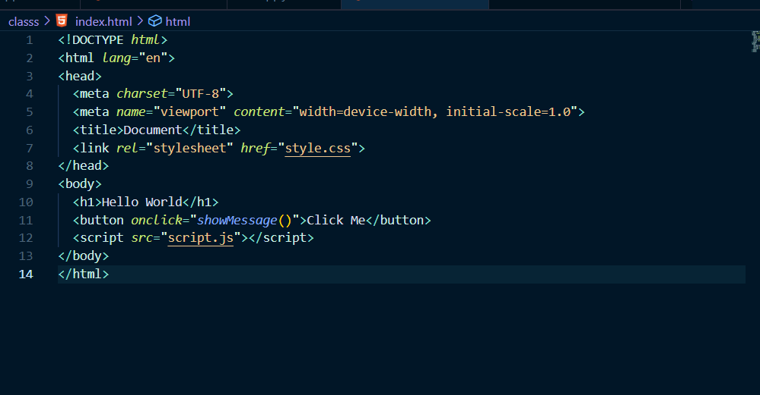
- Index.html
- Style.css
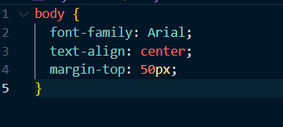

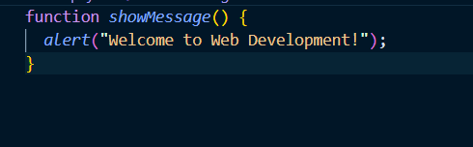
- Script.js

8. Explain the difference between static and dynamic websites. Provide an example of
each.
Static Website:
A static website shows the same content to every visitor. It’s built using simple HTML, CSS, and sometimes a little JavaScript, and doesn’t change unless the developer manually edits it.
Example: A personal portfolio website or a company’s “About Us” page.
Dynamic Website:
A dynamic website shows content that changes based on user actions or data from a database. It uses backend languages like PHP, Node.js, or Python to display updated information.
Example: Facebook or Amazon, where the content changes for each user

9. Research and list five web browsers. Explain how rendering engines differ between
them.
- Google Chrome (Blink)
- Mozilla Firefox (Gecko)
- Apple Safari (WebKit)
- Microsoft Edge (Blink)
- Opera (Blink)
Key Difference between the engines are: -
        - Performance: - Blink is fastest, Gecko focus on privacy, WebKit is optimized for only apply hardware
        - Platform: - Blink and Gecko are cross – platform, WebKit is only for Apple

10. Draw a labelled diagram showing the basic web architecture flow — client, server, database, and APIs.
Browser

Send Request

API
Set Rules for
Interaction
Receive Request
Database
Server
Handles Data
Transfer

